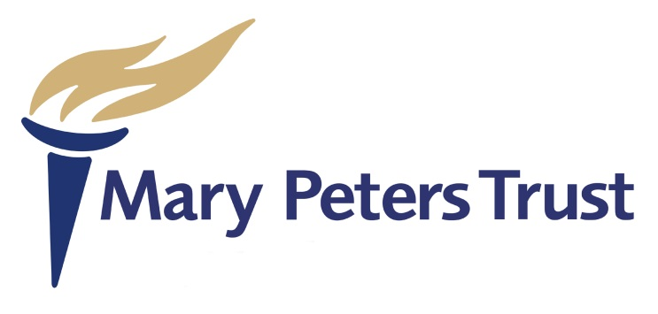

Criteria for consideration of application for Coca Cola Thank You Fund (coaching) awards:

- Purpose

To financially assist talented Mary Peters Trust(the Trust) supported individuals from Ulster in respect of athletes undertaking their level one coaching qualification recognised by the Trust or by organisations who have appointed the Trust as their representative.
2. Criteria

Those athletes of proven ability with such experience as the Directors
consider appropriate to undertake a level one coaching qualification.
All awards will be made at the discretion of the Directors after consideration
of the application form and relevant information.

3. Budget

The Coca Cola Thank You Fund have nominated a maximum sum of
£7,800.00.
4 Eligibility

4.1 Individuals in sports recognised by the Trust are eligible for
consideration for this award. These Individuals must be affiliated to
Governing Bodies recognised by Sport NI.

4.2 Applicants must be aged 16 to 24 years (at date of application) and have
been previously, or are currently being funded, by the Trust.
4.3 Applications will not be considered if they are received after the closing
date.

4.4 The Trust cannot guarantee that any award will fully meet the cost of
the coaching course.

4.5 At first instance, the applicant will receive an initial amount to enable
the applicant to commence the course. On completion of the course the
agreed balance will be paid.

4.6 Each sport will be limited to one award. Depending on the number of
applications.

4.7 The applicants Governing Body must confirm in writing to the Trust an
applicant has completed the Level One coaching course. A copy of the certifi cate also to be forwarded to the Trust once received.

5. Procedure

5.1 Applications should be submitted on the approved application form

5.2 Applications must be signed by the individual, or if under 18 the
parent/guardian and be submitted through the governing body of the sport.

5.3 The Governing Body report must be signed by the nominated officer of the
Governing Body who will liaise with the Trust and ensure that funds are
administered in accordance with the submitted programme, or returned to the
Trust.

5.4 The award must be used in accordance with the Level One Coaching
Qualification detailed by applicant and Governing Body in the application
form.

5.5 The closing date for receipt of applications (with Governing Body reports,
recommendations and ranking lists) is at the end of this document.

5.6 All decisions will be made at the discretion of the Directors of the Trust.

6. Role of Governing Body Nominated Officers

6.1 The Governing Body of each sport, through the nominated officer, must
submit written comment in support of the application lodged for
consideration. These comments should be designed to inform the Trust’s
awards committee of the applicant’s ability, potential, need and commitment
in relation to the criteria.

6.2 A high performance / elite coach or development officer may write the
Governing Body report. The nominated officer must sign the form.

7. Publicity for Coca Cola & the Trust

Governing bodies are asked to support the Trust by ensuring maximum
Publicity for the Coca Cola Thank You Fund and the work of the Trust through publicity including Press, Social Media, Radio & Television.

8. Dates for Application:

Online opening –Wednesday 16th January 2019
Deadline for applications – Friday 15th February 2019 at 5.00pm
Decision by – Friday 15th March 2019

